­­­**Name: Arun Pratap Singh**

**My Project: Zenkart (ecommerce website)**

Overview

The purchasing and selling of goods and services via electronic means, especially the Internet, is referred to as e-commerce or electric commerce. The Internet has grown at the fastest rate in the last decade. Online purchasing, in particular, is a fast-expanding e-commerce sector. Online stores are typically open 24 hours a day, and many consumers have access to the Internet at both work and home. A successful online business is more than just a well-designed website with dynamic technical features that appears in multiple search engines.

Zenkart is a clone of flipkart.

Homepage:-

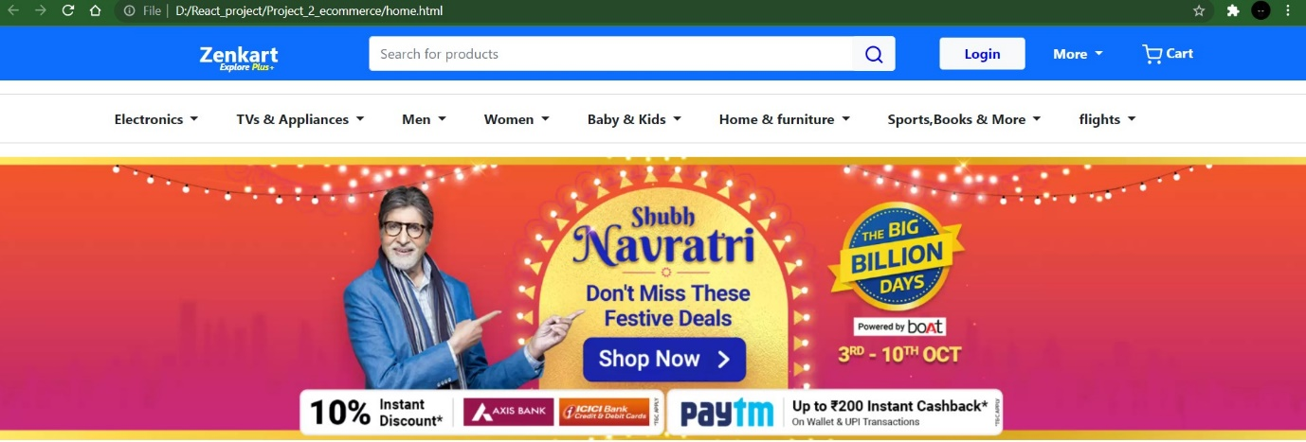

**Technology Used:**

**Front-End:**

1. Html

2. CSS

3. Bootstrap

4. React

**Dynamic:**

1. JavaScript

2. Ci/cd with AWS

3. Login and logout(oauth and jwt)

**Database:**

1. Mongoose db

2. Json Data

**Code Compiler:**

1. Visual studio code

2. Git bash

3. Git hub

4. Node js.

**Goals:**

**For Users:-**

1. Home Page

2. Login Page

3. Cart

4. Product Page

5. Checkout Page

6. Customer Details Page

7. Login and Logout Page

**For Admins:-**

**1.Dashboard**

**2.Add product**

**3.Delete product**

**4.Update product**